Angular CLI tutorial

1. Overview about Angular:

Angular CLI is a Front-end Framework, which can combine many typescript (the extension javascript) files and html files become one project like Eclipse Java Project or Android Studio Project.

In this example, I will use Angular CLI 6 to make a sample Angular project, which can satisfy CRUD feature for Student Entity with uploading and downloading file from Spring MVC 4 server via Http Requests and Http Responses for showing Student’s Image.

1. Example project user guilde:

* To make an Angular project, we must have NodeJS Programming Environment and it’s Angular CLI extension in our computer, see this link for installing those thing:

<https://github.com/angular/angular-cli/wiki>

* After that we can run Angular project by open Command Prompt inside a target folder that we want and type:

ng serve

* After the progress complete, you will see the command prompt like that:

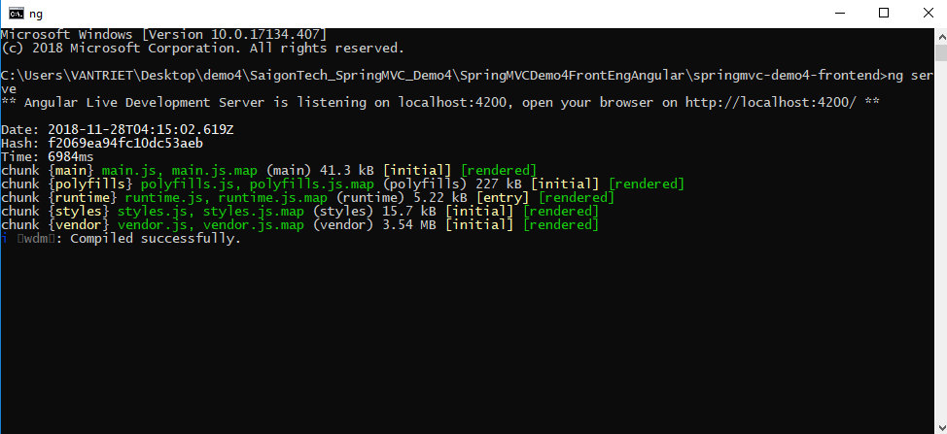

* Now access the address <http://localhost:4200>/login in your browser to see the login page.

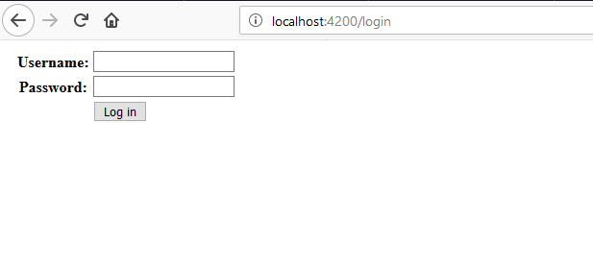

* Login with username admin and password 123abc to access the student list page.

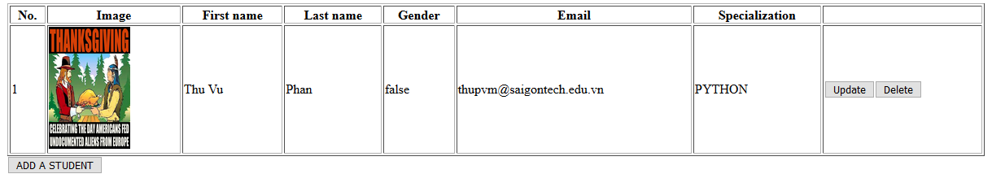

In Angular, we cannot location.href like normal html. Therefore, we should split out project into many component and define them on

app-routing.module.ts navigate link like:

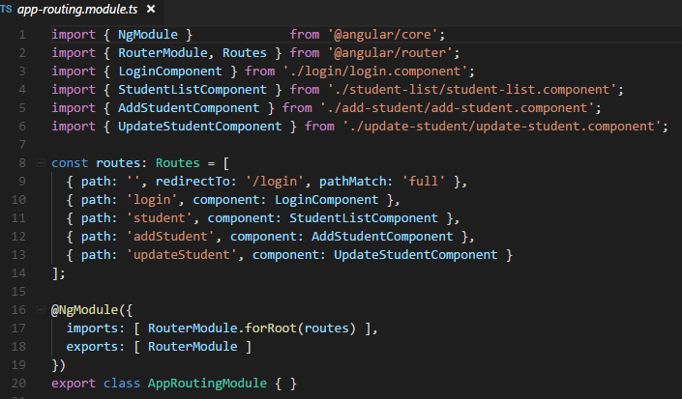

* For adding new student to the website, click the button ADD A STUDENT under the table and it will navigate us to the adding page:

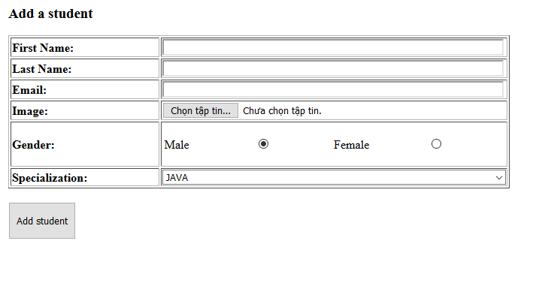

Fill all the information and click Add student to add a new student and relocate to the student list page:

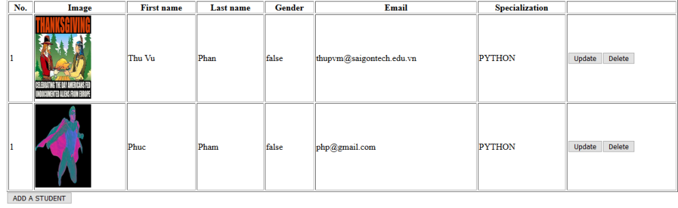

* For update student’s information, we just click the Update button in the row of that student to access the update page like this:

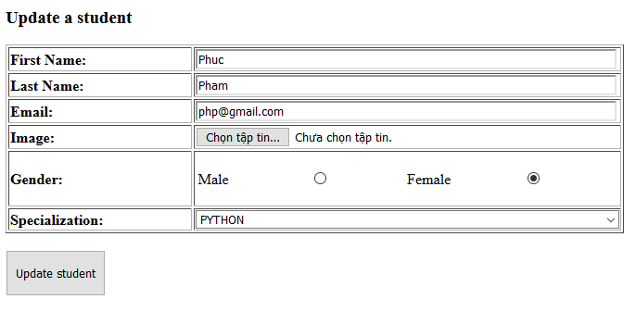

When you want to finish edit this student information, click Update student to relocate to the student page and finish your action.

* For removing students, you just need to click on the Delete button in the row of that student to delete the student that you want and the page will show a notification like this:

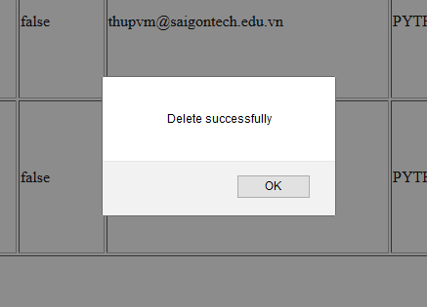

End